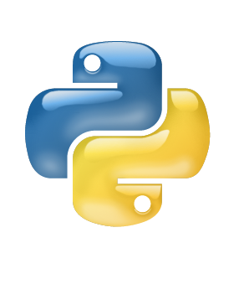

**Introduction to**

Python

Class viii

Lab 16

**Lab Objectives:**

* What is Python?
* History of Python
* Reasons to learn Python
* What can you do with Python?

What is python?

It’s true that python is a heavy bodied non venomous snake. But we are not talking about that one. Here you are going to learn an object oriented high level programming language which is also named “Python”. But is it really like a snake? Let’s check this out.

History of python

The name python comes from the surreal British comedy group “*Monty Python*”, not from the snake. During the vacation of Christmas in 1989 a person named



Figure: Monty Python Flying Circus

Guido Van Rossum was thinking about a programming project for spending his one-week vacation properly. He had a computer in his home but he could not find any work to do. So he decided to develop an interpreter for his own scripting language**.**

*Fig: Guido Van Rossum*

Rossum was a huge fan of Monty Python Flying Circus. So after developed that he chooses to call that language “Python” and now python is the world class top rated programming language.

Python is 10x faster than Java, 100x faster than C programming and 120x faster than PHP. Yet python is the easiest and powerful programming language.

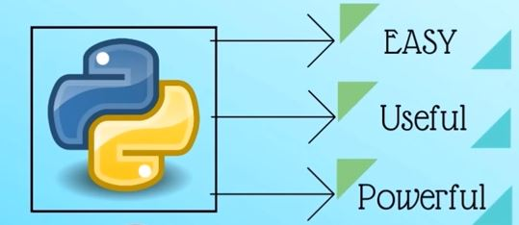

Reasons to Learn Python

|  |  |  |
| --- | --- | --- |
|  |  |  |
| * Easy to read and easy to learn | * No programming skill required | * Beginner or expert friendly |

|  |  |  |
| --- | --- | --- |
|  |  |  |
| * Big open source and newest trends | * Big Libraries for   many things | * Great for   validating  ideas for any company |

There is no doubt that python is pretty easy. But what is your benefit to work with python? Do you know what type of product you can develop using python? Oh! ok, keep patience.

**What can you do with python?**

1. Web development

You can use python to create web applications on many levels of complexity.

There are many excellent python web frameworks including ***Django, Flask, pyramid*** etc.



*Fig: Web site*

1. Data Analysis

Python is the leading language of choice for many data scientists. Python has grown in popularity within this field, due to its excellent libraries including ***NumPy*** and ***Pandas*** and its superb libraries for data visualization like ***Matplotilb*** and ***Seaborn***.



1. Machine Learning

What if you could predict customer satisfaction or analyze what factors will affect household pricing or to predict stocks over the next few days, based on previous years’ data?

There are many wonderful libraries implementing machine learning algorithms such as ***Scikit-Learn, NLTK and TensorFlow.***

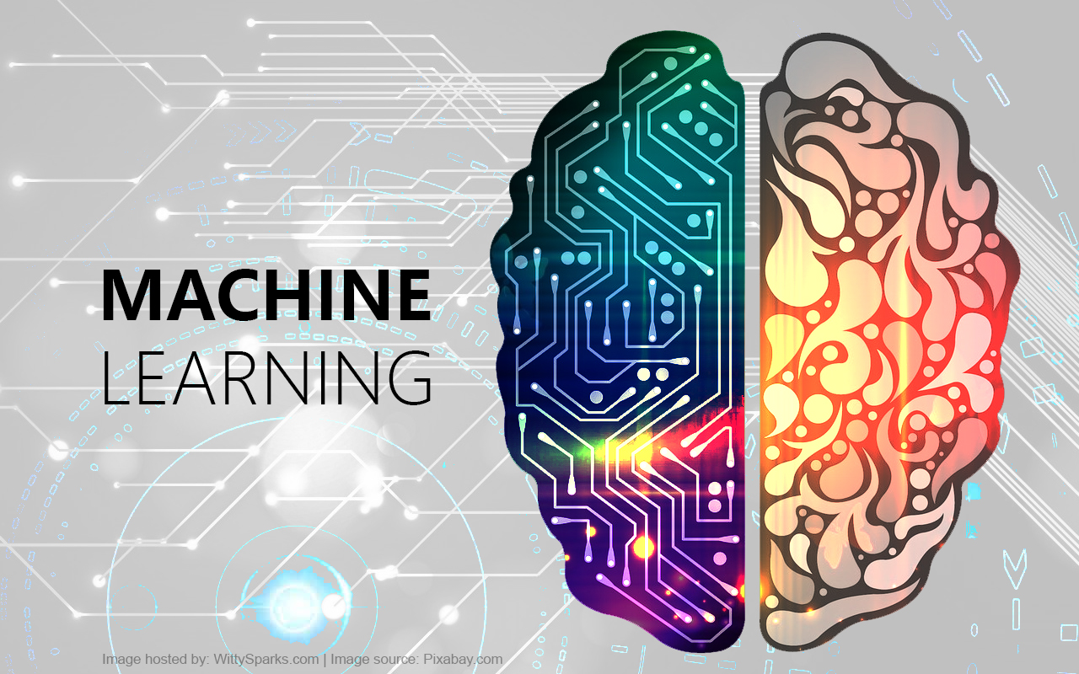

1. Computer Vision

You can do many interesting things such as Face detection, color detection while using ***OpenCv*** and Python.



1. Raspberry Pi

Raspberry pi can be used as the brain for your robot in order to perform various actions and/or react to the environment. The coding on a Raspberry Pi can be performed using Python. The possibilities are endless.

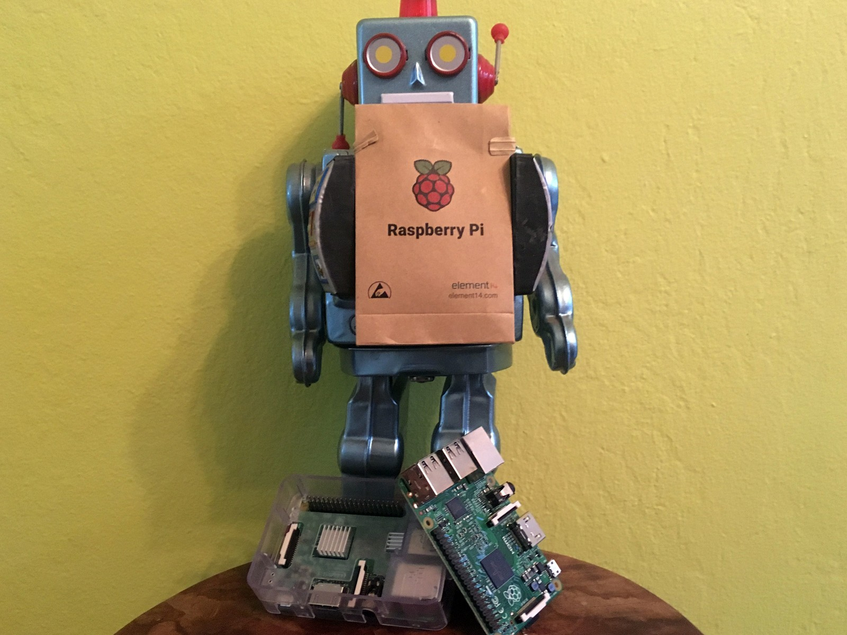

Fig: Pi Robot

1. Game development

You can easily create a video game using module ***Pygame.*** Basically you have to use python to write the logic of the game.

Pygame application can run on both computer and Android devices.



Fig: Video Game

1. Android app development

Android application can be also made by python using Kivy module.

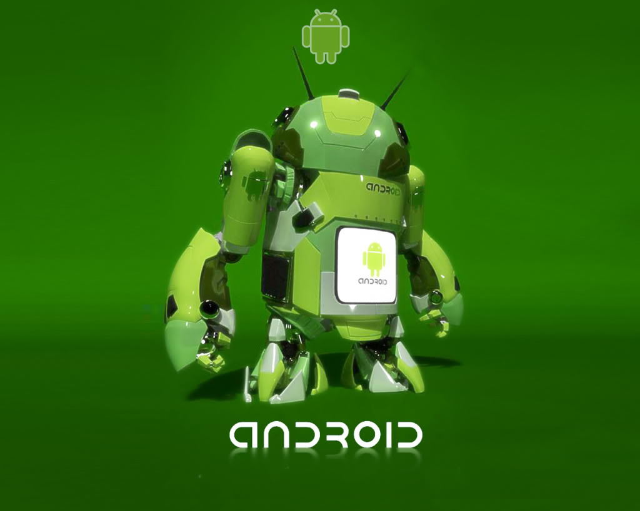

There are also thousands of tasks to do with python such as web scraping, Browser Automation, GUI Development etc. We’ll learn this stuff later.

**Summery:**

* Python is not a snake, it’s a high-level programming language.
* Python is named according to the famous comedy group Monty Python Flying Circus
* Python is an open source cross platform language and you don’t need any prior programming skills to start learning python.
* You can easily develop web application, android application, Video Game, robot using python.

Exercise

Draw a line from the term to the correct word

|  |  |
| --- | --- |
| Name/ Library / Module  ------------------------------------ | Is /used for  ---------------------------------- |
| Python | Game Development |
| Django | Computer Vision |
| PyGame | Machine Learning |
| Kivy | Android App development |
| TensorFlow | Programming Language |
| OpenCV | Web Development |